34.110: 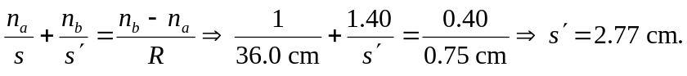 This distance is greater than the normal eye, which has a cornea vertex to retina distance of about 